**OUTPUT:**

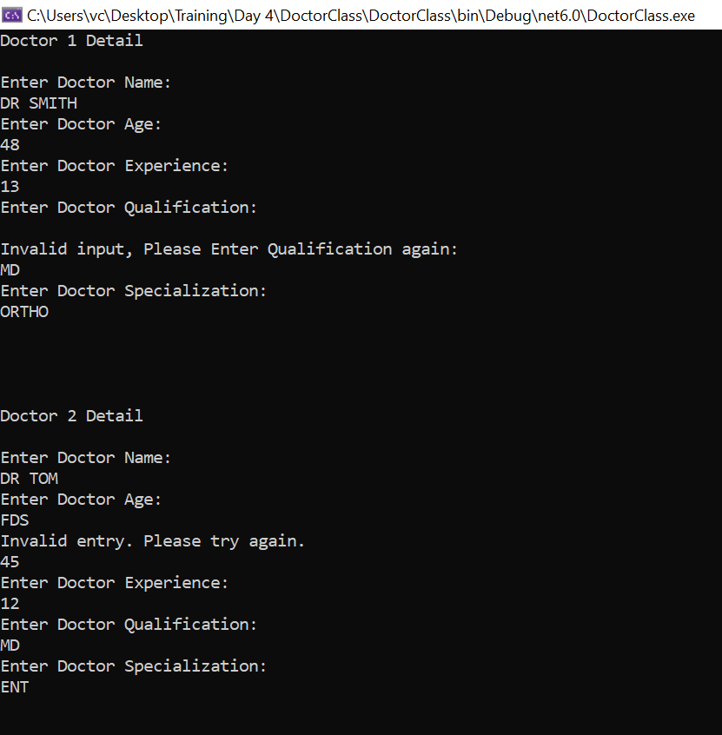



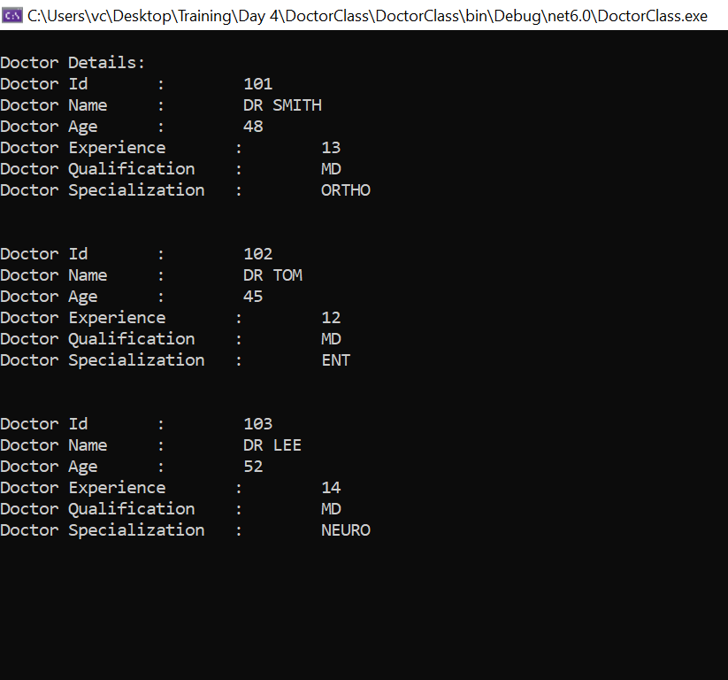

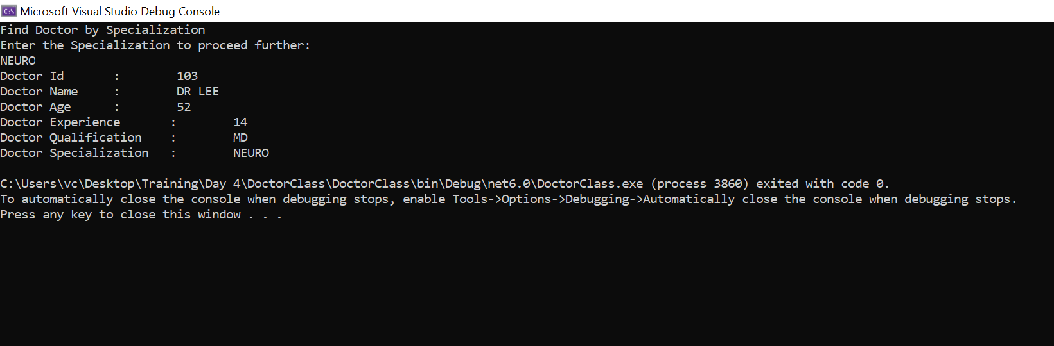

**CODE:**

**Program.cs**

using DoctorClass.Models;

namespace DoctorClass

{

public class Program {

void FindDocBySpecialization(Doctor[] docs)

{

Console.WriteLine("\n\n\n");

Console.WriteLine("\n\n\nFind Doctor by Specialization");

Console.WriteLine("Enter the Specialization to proceed further:");

string spcl = GetStringInput("Specialization");

bool flag = false;

for (int i = 0; i < docs.Length; i++)

{

if (docs[i].Specialization == spcl)

{

flag = true;

docs[i].PrintDetails();

}

}

if(!flag)

{z

Console.WriteLine("Sorry we coudn't find any doctors!");

}

}

string GetStringInput(string FieldName)

{

string? inp;

do

{

inp = Console.ReadLine();

if (string.IsNullOrWhiteSpace(inp))

Console.Write($"Invalid input, Please Enter {FieldName} again:\n");

} while (string.IsNullOrWhiteSpace(inp));

return inp;

}

int GetIntInput()

{

int num;

while (!int.TryParse(Console.ReadLine(), out num))

{

Console.WriteLine("Invalid entry. Please try again.");

}

return num;

}

Doctor CreateDoctorDetails(int id)

{

Console.WriteLine($"Doctor {id-100} Detail\n");

Doctor doc = new Doctor(id);

Console.WriteLine("Enter Doctor Name:");

doc.Name = GetStringInput("Name");

Console.WriteLine("Enter Doctor Age:");

doc.Age = GetIntInput();

Console.WriteLine("Enter Doctor Experience:");

doc.Experience = GetIntInput(); ;

Console.WriteLine("Enter Doctor Qualification:");

doc.Qualification = GetStringInput("Qualification");

Console.WriteLine("Enter Doctor Specialization:");

doc.Specialization = GetStringInput("Specialization");

return doc;

}

static void Main(string[] args)

{

Program pro = new Program();

Doctor[] docs = new Doctor[3];

for (int i = 0; i < docs.Length; i++)

{

docs[i] = pro.CreateDoctorDetails(101 + i);

Console.WriteLine("\n\n\n");

}

Console.WriteLine("\n\n\nDoctor Details:");

for (int i = 0; i < docs.Length; i++)

{

docs[i].PrintDetails();

Console.WriteLine("\n");

}

pro.FindDocBySpecialization(docs);

}

}

}

**Doctor.cs**

using System;

using System.Collections.Generic;

using System.Linq;

using System.Text;

using System.Threading.Tasks;

namespace DoctorClass.Models

{

class Doctor

{

int Id { get; set; }

public string Name { get; set; }

public int Age { get; set; }

public int Experience { get; set; }

public string Qualification { get; set; }

public string Specialization { get; set; }

/// <summary>

/// Constructor for Intialization of Object

/// </summary>

/// <param name="id">Id for Doctor as (int)</param>

public Doctor(int id) => Id = id;

/// <summary>

/// Function that prints all Details of particular Doctor

/// </summary>

public void PrintDetails()

{

Console.WriteLine($"Doctor Id\t:\t {Id}");

Console.WriteLine($"Doctor Name\t:\t {Name}");

Console.WriteLine($"Doctor Age\t:\t {Age}");

Console.WriteLine($"Doctor Experience\t:\t {Experience}");

Console.WriteLine($"Doctor Qualification\t:\t {Qualification}");

Console.WriteLine($"Doctor Specialization\t:\t {Specialization}");

}

}

}